Exploratory Pattern One

* **a name for the pattern: Citation&ReferenceSearch**
* **a wireframe picture** 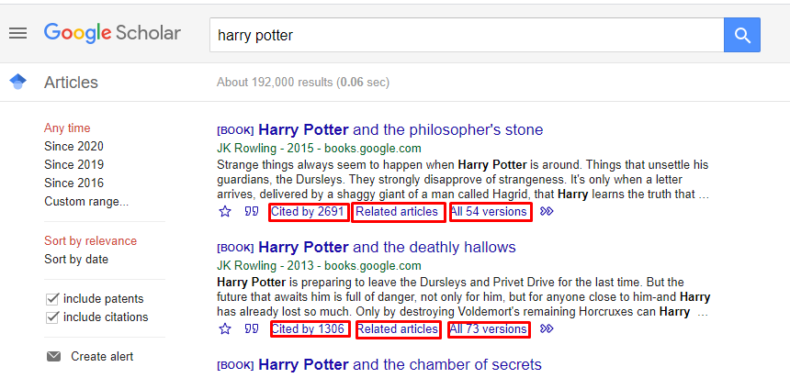
* **use when**

1. Use to enable users to look for similar search requests
2. Use to enable users identify similar items
3. Use to enable users get additional information by clicking and selecting

* **how** (describes how the pattern may be applied)

This pattern is easy to use, user just have to click and selected to get the information. Instant feedback.

The pattern may be applied to search for similar pieces of information. For example, user that searches for an article may see the connections between it and other articles, related articles, other versions or articles that cited it.

* **a discussion of** how you have applied this pattern in your own information seeking.

I am usually applying this pattern when looking to similar items. To find collections and related items, to find out where the item was used, cited or referenced. This helps with keeping the track of specific item. It helped me a lot with doing research on transportation ethics. I was able to find a lot of papers about this particular subject.